**Neptune3 Firmware Update Guide**

* **Files description：**



Screen firmware



Motherboard firmware

* **Preparation：**

1. Format the TF card.

File system: FAT32 Allocation unit size: 4096 bit

1. Copy the two files into the root directory of the TF card.

* **Screen firmware update：**

1. As shown like pic 1, disassemble the back shell.
2. Pay attention to the plug location, insert the TF card.

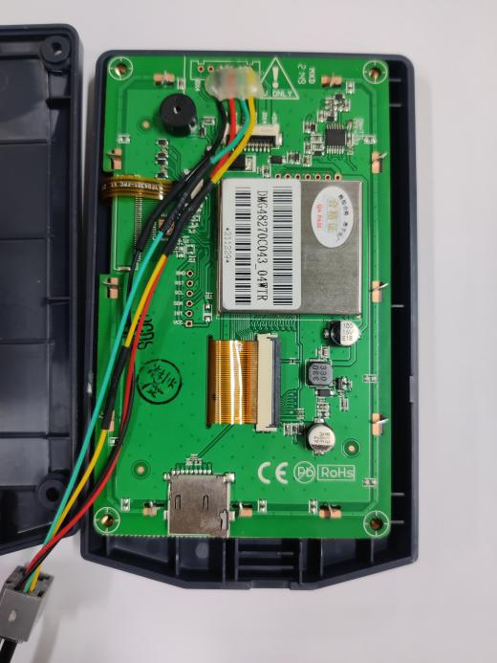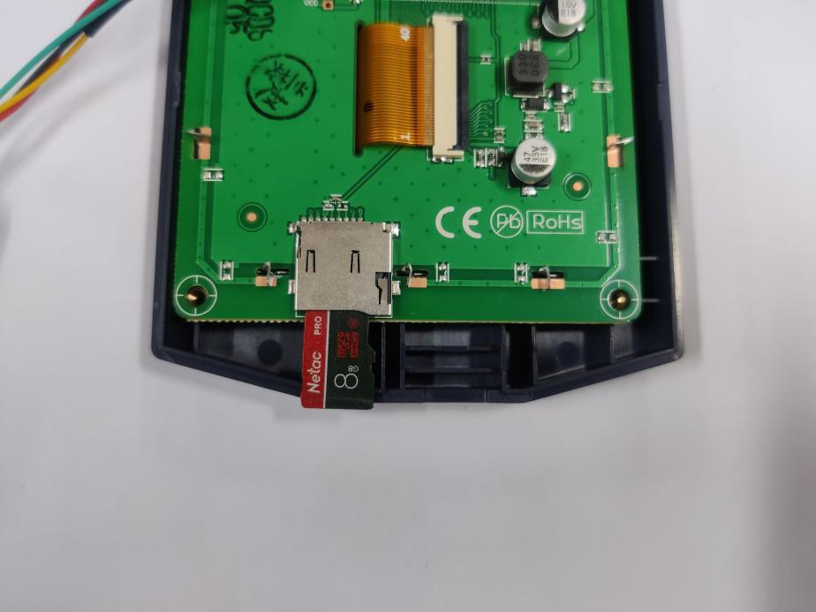

**Pic 2**

**Pic 1**

1. Reboot the power, wait until the firmware finish loading. The interface shows like below after the firmware loads.(Screen firmware update time: around 70s)

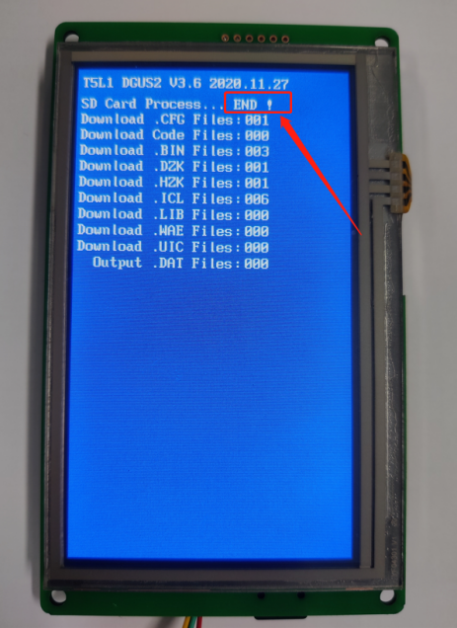

* **Motherboard firmware update：**

Insert the TF card into the machine. Reboot the power, wait until the firmware finish loading. The interface shows like pic3 when the firmware is loading. It will enter the interface like pic4 once the firmware is updated.

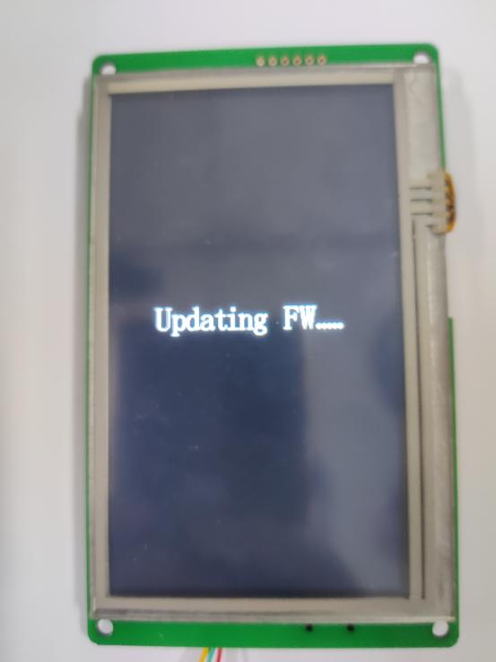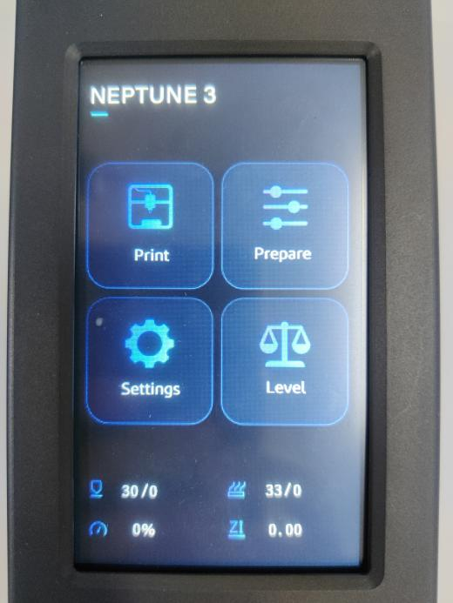

**Pic 4**

**Pic 3**

**Remind:**

If the leveling fails or the homing fails, please try to restart the power or choose to restore the factory settings in the settings.

The leveling grid data will be cleared after a factory reset and must be re-leveled.

**Leveling Temperature Recommendations:**

Hot end temperature: 0 ℃

(in order to avoid fan rotation and temperature affecting the leveling accuracy)

Hot bed temperature:

the temperature required by the filament +5 °C

(To avoid the leveling effect due to the thermal deformation of the hot bed)